PIZZA SALES SQL QUERIES
- Total Revenue
SELECT SUM(total_price) AS total_revenue
FROM pizza;
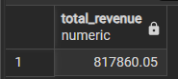
- Average Order Value
SELECT ROUND(SUM(total_price)/COUNT(DISTINCT(order_id)),2) AS avg_order_value FROM pizza;
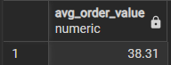
- Total Pizza Sold
SELECT SUM(quantity) AS total_pizza_sold
FROM pizza;

- Total Orders
SELECT COUNT(DISTINCT order_id) AS total_orders
FROM pizza;
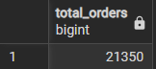
- Average Pizzas Per Order
SELECT ROUND(SUM(quantity)::NUMERIC / COUNT(DISTINCT order_id),2) AS avg_pizza_per_order FROM pizza;
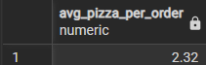
- Daily Trends For Total Orders
SELECT
TO_CHAR(order_date, 'Day') AS day_name,
COUNT(DISTINCT order_id) AS total_orders
FROM pizza
GROUP BY
TO_CHAR(order_date, 'Day'),
EXTRACT(DOW FROM order_date)
ORDER BY EXTRACT(DOW FROM order_date);
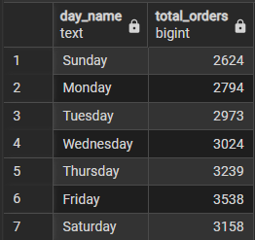
- Hourly Trend For Total Orders
SELECT
TO_CHAR(order_time, 'HH12 AM') AS hour,
COUNT(DISTINCT order_id) AS total_orders
FROM pizza
GROUP BY EXTRACT(HOUR FROM order_time), TO_CHAR(order_time, 'HH12 AM')
ORDER BY EXTRACT(HOUR FROM order_time);
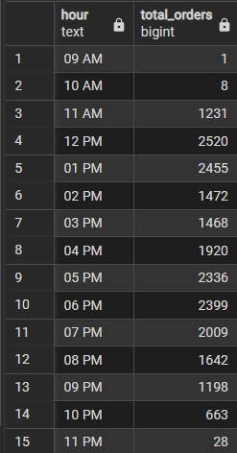

- Sales % By Pizza Category
SELECT
pizza_category,
SUM(total_price) AS total_sales,
ROUND(
SUM(total_price)::NUMERIC * 100 / SUM(SUM(total_price)) OVER (),
2
) AS sales_percentage
FROM pizza
GROUP BY pizza_category;
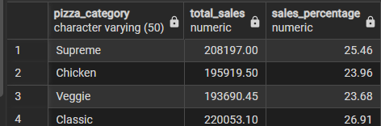
- Sales % By Pizza Size
SELECT pizza_size, SUM(total_price) AS total_revenue,
ROUND(SUM(total_price):: NUMERIC * 100 / SUM(SUM(total_price)) OVER(),2)
AS sales_percentage
FROM pizza
GROUP BY pizza_size;
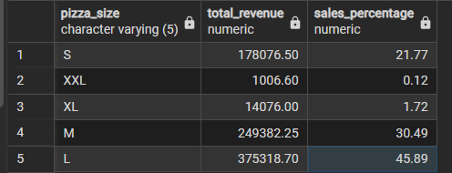
- Total Pizza Sold By Pizza category
SELECT pizza_category, SUM(quantity) AS total_pizzas
FROM pizza
GROUP BY pizza_category;
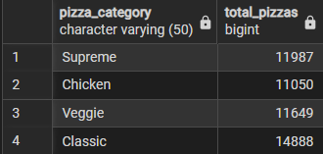

- Top 5 Pizza Sellers By Total Pizzas Sold
SELECT pizza_name, SUM(quantity) AS total_pizzas_sold
FROM pizza
GROUP BY pizza_name
ORDER BY total_pizzas_sold DESC
LIMIT 5;
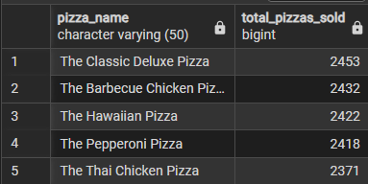
- Worst 5 Seller By Total Pizzas Sold
SELECT pizza_name, SUM(quantity) AS total_pizzas_sold
FROM pizza
GROUP BY pizza_name
ORDER BY total_pizzas_sold
LIMIT 5;
